Joseph Sharp Halpin

Project Partner: Dayton Flores

**CPE301 – SPRING 2018**

Midterm 2

**DO NOT REMOVE THIS PAGE DURING SUBMISSION:**

The student understands that all required components should be submitted in complete for grading of this assignment.

|  |  |  |  |
| --- | --- | --- | --- |
| **NO** | **SUBMISSION ITEM** | **COMPLETED (Y/N)** | **MARKS**  **(/MAX)** |
| 1 | COMPONENTS LIST AND CONNECTION BLOCK DIAGRAM w/ PINS |  |  |
| 2. | INITIAL CODE OF TASK 1/A |  |  |
| 3. | INCREMENTAL / DIFFERENTIAL CODE OF TASK 2/B |  |  |
| 3. | INCREMENTAL / DIFFERENTIAL CODE OF TASK 3/C |  |  |
| 3. | INCREMENTAL / DIFFERENTIAL CODE OF TASK 4/D |  |  |
| 3. | INCREMENTAL / DIFFERENTIAL CODE OF TASK 5/E |  |  |
| 4. | SCHEMATICS |  |  |
| 5. | SCREENSHOTS OF EACH TASK OUTPUT |  |  |
| 5. | SCREENSHOT OF EACH DEMO |  |  |
| 6. | VIDEO LINKS OF EACH DEMO |  |  |
| 7. | GOOGLECODE LINK OF THE DA |  |  |
|  |  |  |  |
|  |  |  |  |

1. **COMPONENTS LIST AND CONNECTION BLOCK DIAGRAM w/ PINS**

ATmega328p Xplained Mini x 2, nRF24L01 x 2, LM34, LED.

Task 1:

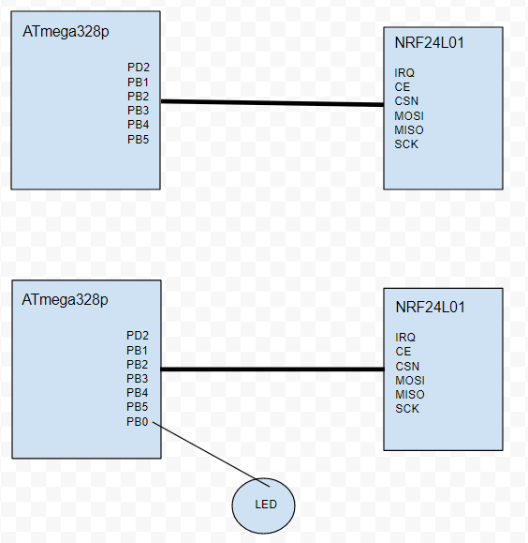

Task 2:

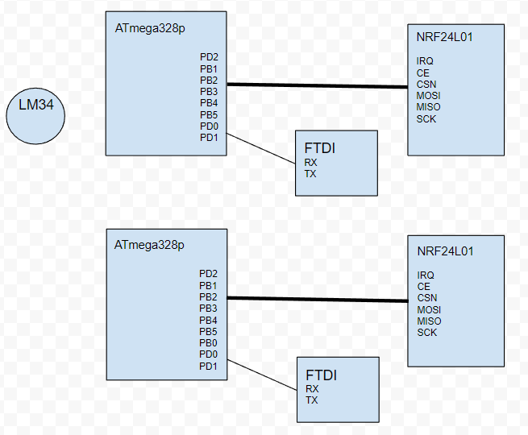

1. **INITIAL/DEVELOPED CODE OF TASK 1**

Transmit Code

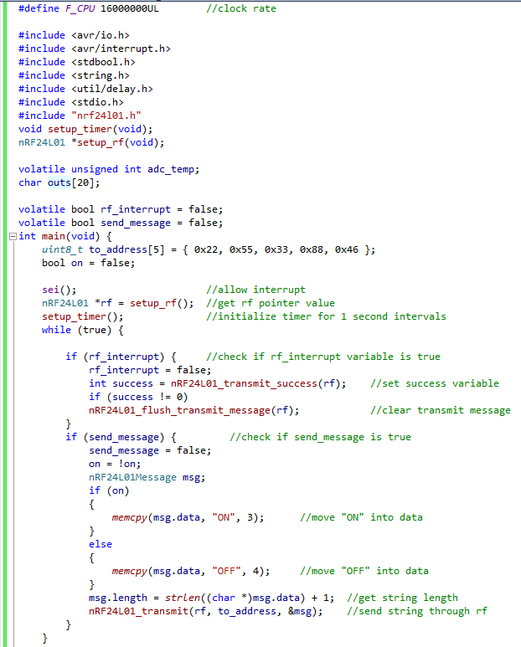

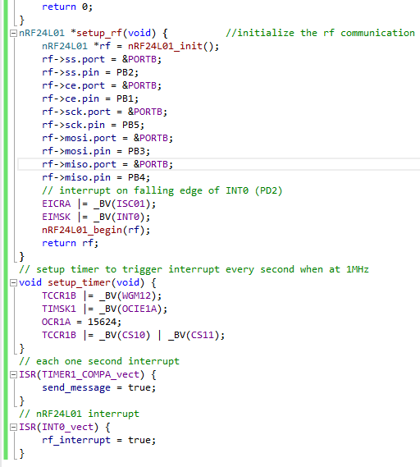

Receive Code

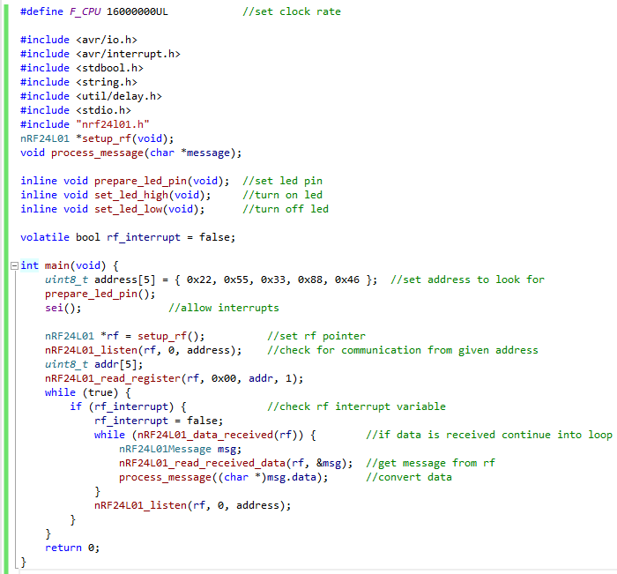

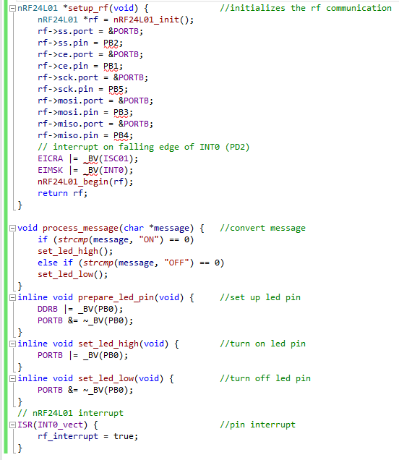

1. **INITIAL/DEVELOPED CODE OF TASK 2**

Transmit Code

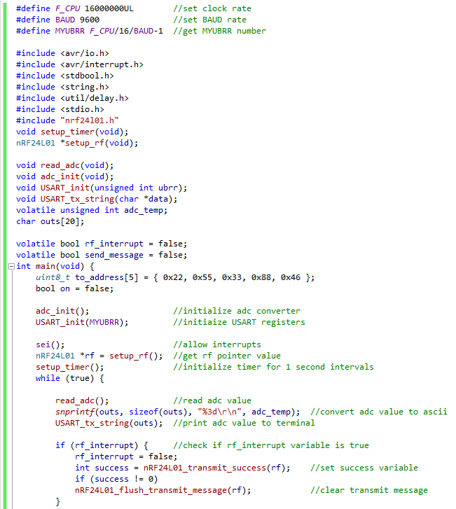

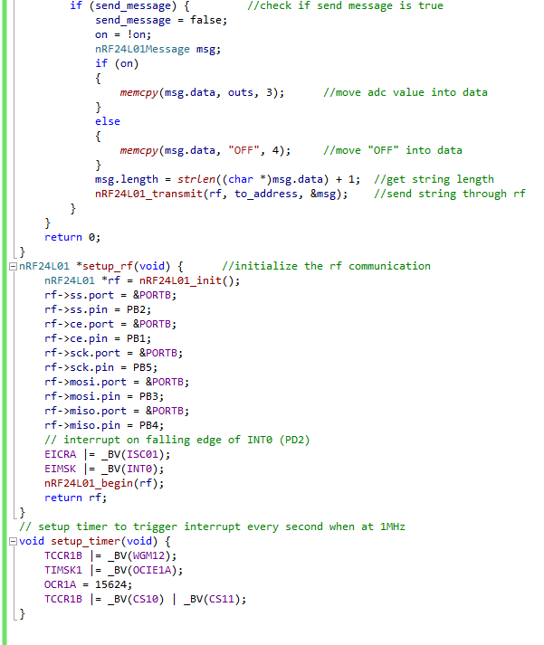

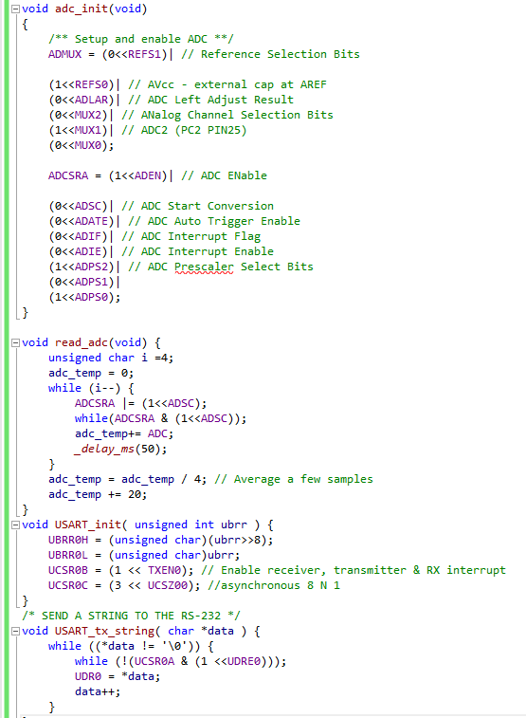

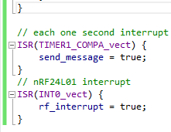

Receive Code

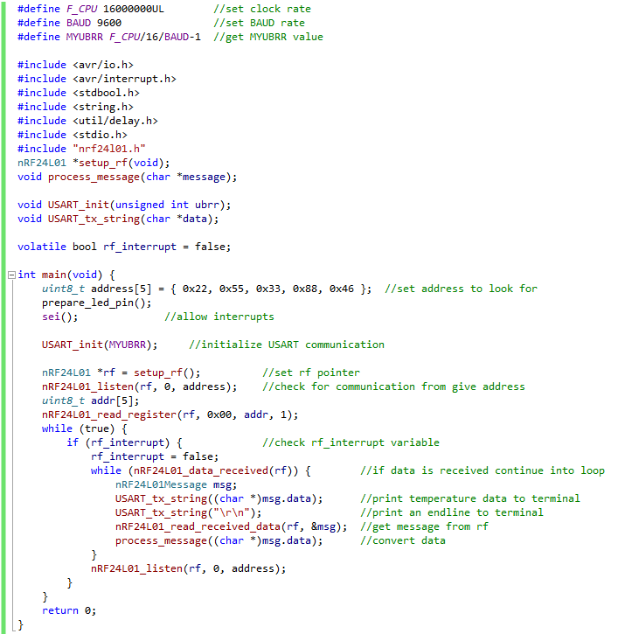

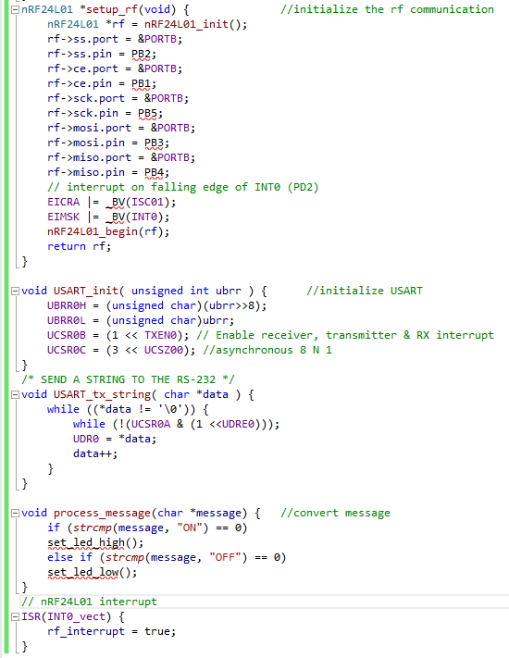

1. **SCHEMATICS**

Task 1:

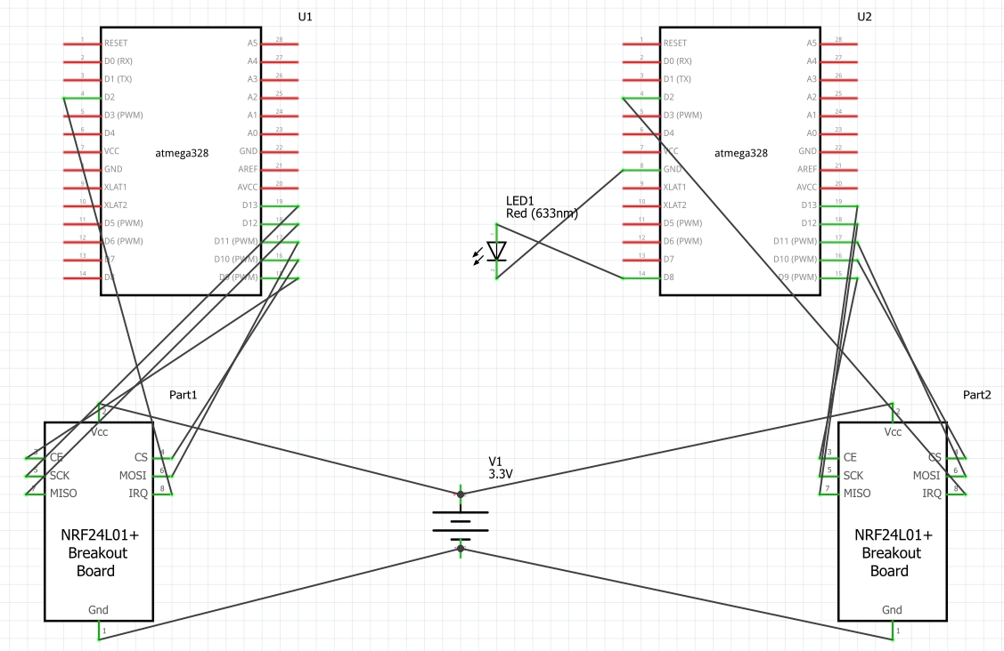

Task 2:

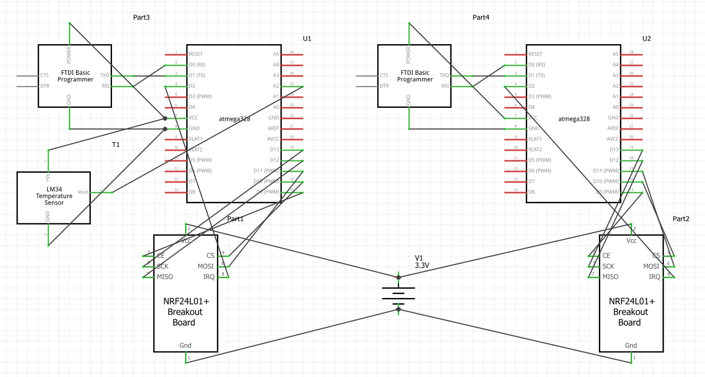

1. **SCREENSHOTS OF EACH TASK OUTPUT**

Transmitted Data:

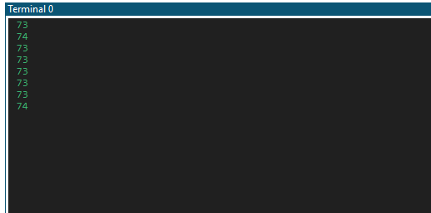

Received Data:

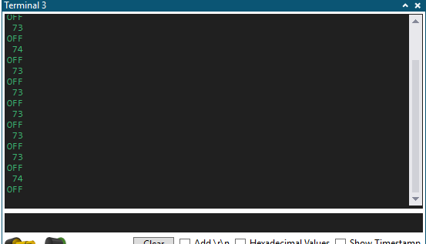

1. **SCREENSHOT OF EACH DEMO (BOARD SETUP)**

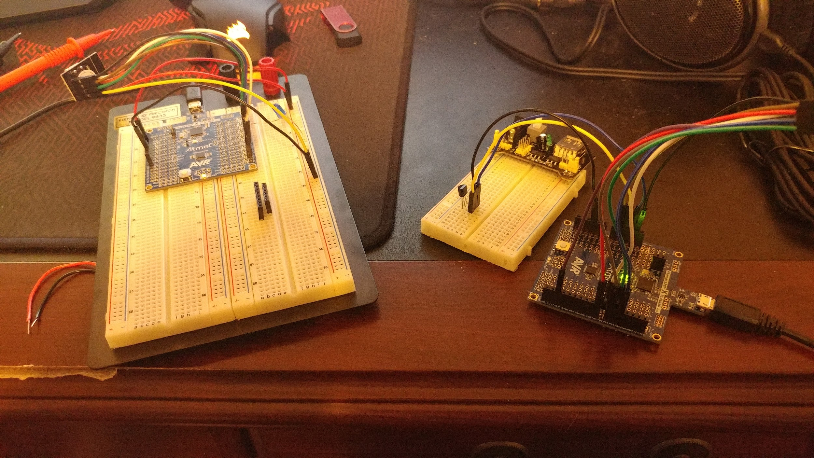

1. **VIDEO LINKS OF EACH DEMO**

<https://youtu.be/omP62z9j9RM>

1. **GITHUB LINK OF THIS DA**

<https://github.com/jsharpin/My-Repos>

**Student Academic Misconduct Policy**

<http://studentconduct.unlv.edu/misconduct/policy.html>

“*This assignment submission is my own, original work*”.

Joseph Sharp Halpin